Ecotex®: New PVC-free outdoor textile range of Heytex
Environmentally friendly for medium-term outdoor use
Bramsche/Germany in September 2020
At Heytex we set standards with our innovative products with the aim to maximise the benefit for our customers and society.
Changing requirements and increased environmental awareness require the development of new products. This also applies to the banner market.
Heytex presents its new PVC-free ecotex® line. New PVC-free textiles for medium-term outdoor use - with high sustainability.
Already in March 2019, Heytex launched its new ecotex® frontlit on the market and is now extending its portfolio by a PVC-free textile mesh. To complete the range, a backlit and a blackback are also expected soon.
The new ecotex® materials are available in production widths up to 500 cm (frontlit) and 505 cm (mesh) and are perfect for UV, solvent, ecosolvent and latex printing. Due to their high tear strength and dimensional stability, they can withstand high wind loads and are ultra-light (frontlit up to 50% less than conventional frontlits). This facilitates processing, reduces transport costs and saves CO2.
Environmentally friendly, sustainable & health-conscious.
The material is free of plasticizers, phthalates and isocyanate-containing compounds.
The ecotex® materials are the unique alternative for outdoor applications when PVC banners are not desired (with a proven durability of 12 months in Northern European outdoor use).
In addition, fire-certified according to DIN 4102 B1 and EN13501-1, they even comply with official building regulations, thus saving the need to stock both flame-retardant and non-flame-retardant products at the same time.
Ecotex® textiles - overwhelming printing dimension with vivid colour fastness and required flame retardancy - environmentally conscious and resource-saving - the textile alternative.

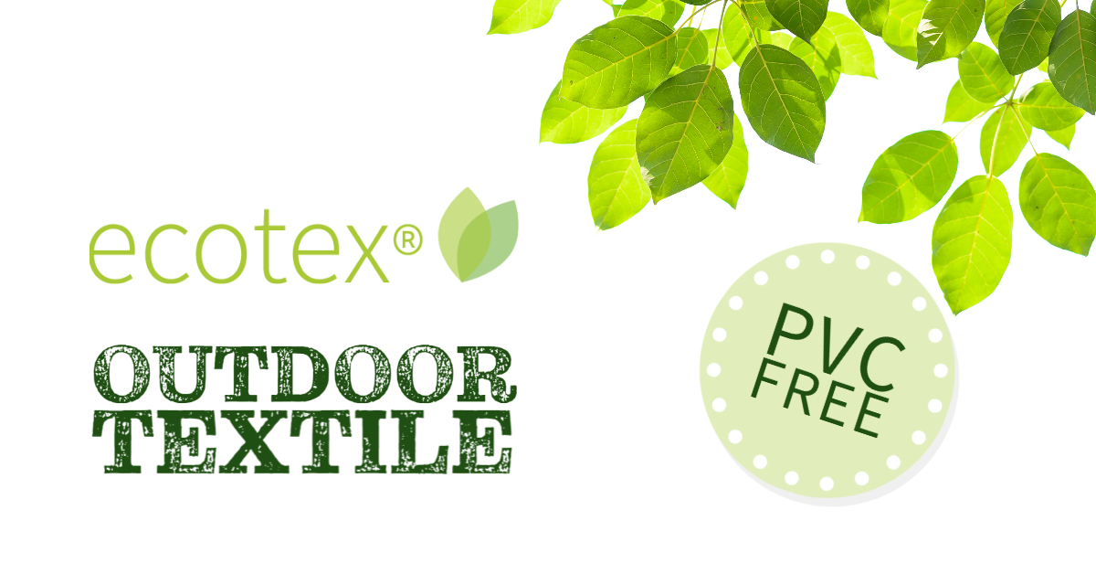

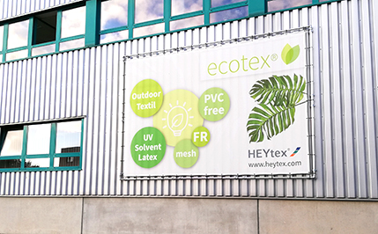

https://heytex.com/en/produkte/heysign-ecotex/

