Heytex presents: New Plant Manager
From „Hands-on“ and „Can-do“ – From development to plant management
Bramsche/Germany im Juni 2020
At #heytex we believe that characters will help our brand move forward.
We are therefore proud to introduce Marko Rother as new plant manager for the headquarters plant in Bramsche/Engter.
Marko Rother has been working for Heytex since 2014 and starts his career in the development department where he is also responsible for important projects for the Heytex Group. From 2015 to 2019, he will also head the development department at the Heytex subsidiary in Zhangjiagang, China. He also looks back on field assignments at the Heytex subsidiaries in Pulaski, USA and at the second German location Neugersdorf. Since his return from China, Marko has been in charge of the development department, quality assurance and the laboratory.
Thus, Marko Rother can experience and live all positive virtues of the three continents and likes to make them his own - pragmatism - enthusiasm - engineering thinking. His comprehensive knowledge of the market supplied by Heytex will certainly help him in this respect.
In his new role as plant manager, it is now his greatest challenge to implement the generation change in everyday production in order to ensure the safeguarding and expansion of the business at the Bramsche location in unsettled economic times. To this end, knowledge as a resource is to be secured, imparted and further expanded. In this way Marko Rother combines practice with knowledge, planning with implementation, sustainability with development, all in the spirit of "hands-on & can-do".
We are looking forward to the next steps!
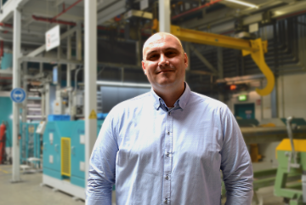
Image capture
Marko Rother, Plant Manger, in his natural habitat

